**Project Statement:**

Make a digital music player that can play multiple songs on a breadboard speaker. Inputs include a button press for selecting the next song to play. There are also buttons to navigate through the songs: pause, jump forward/backwards in a song, skip.

**Circuit Diagram:**

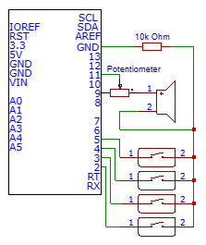

**Materials:**

* **Speaker**
* **4 buttons**
* **Resistors**
* **Potentiometer**

**High Level Algorithm:**

When the program starts:

Play First Song

IF(next_song button is pressed) {

Trigger interrupt and play next song

}

IF(Pause button is pressed) {

Halt program ; songs pauses

}

IF(FastForward button is pressed)

{

Jump ahead a certain number of seconds in the current song

}

IF(Rewind button is pressed) {

Jump backwards a certain number of seconds in the current song

}

Otherwise, determine the appropriate voltage to send to the speaker based on the

notes that need to be played.